WAZUH WINDOWS CHROME HISTORY MONITOR
Professional Technical Documentation & Junior Implementation Guide
Version 1.0
14 September 2026
Current scope: Chrome browsing-history collection
Next planned scope: browser upload detection
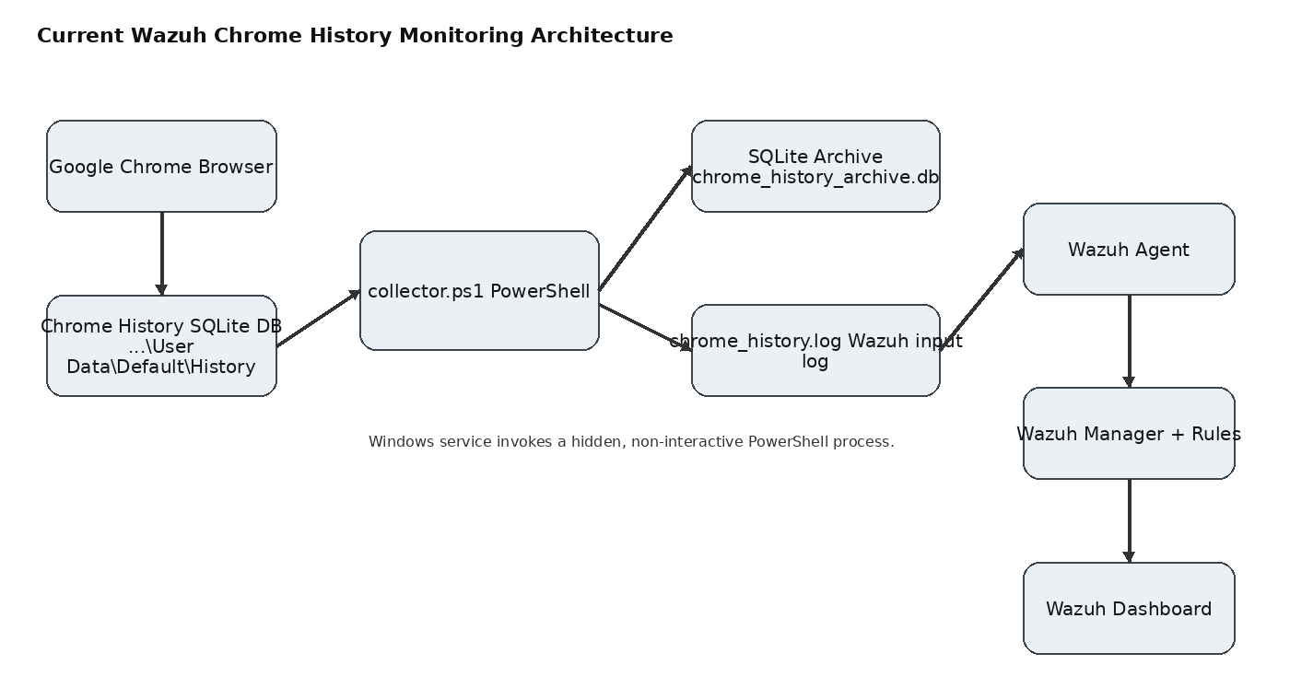
End-to-end architecture

1. Executive Summary
This project builds a lightweight endpoint telemetry pipeline on Windows that extracts newly created Google Chrome browsing-history records, archives them locally in SQLite, writes only newly discovered events to a dedicated log file, and lets the Wazuh Agent forward those events to the Wazuh Manager and Dashboard. The original objective is broader—ultimately detecting file-upload activity—but Chrome-history monitoring was implemented first as the foundation.
Current status Chrome history collection, local archiving, Wazuh ingestion, custom Chrome-history classification, benign collector-noise suppression, and background service execution are operational. Upload detection is the next phase.

- Collector polling interval: 5 seconds.
- Incremental cursor: Chrome visits.id, persisted through the SQLite archive.
- Archive: C:\ProgramData\ChromeHistoryMonitor\chrome_history_archive.db.
- Wazuh log: C:\ProgramData\ChromeHistoryMonitor\chrome_history.log.
- Collector diagnostics: collector.log; service diagnostics: service.log.
- SQLite concurrency protection: WAL + busy_timeout + one transaction per cycle.
- Custom rules: 100200 (Chrome history) and 100201 (specific 91816 suppression).

2. Goals and Scope

2.1 Goals
- Continuously observe Chrome browsing history.
- Collect only new visits rather than repeatedly sending the entire history.
- Persist progress across service restarts.
- Provide a Wazuh-compatible event stream.
- Run continuously as a Windows service without a visible PowerShell window.
- Provide a stable foundation for future upload detection.

2.2 Current limitations
- Chrome history is contextual evidence, not proof of a file upload.
- Current implementation targets Chrome's Default profile.
- No upload correlation is implemented yet.
- No uploaded-file content is captured.

3. Architecture
Figure 1 — Current architecture
Component | Location / Technology | Responsibility
Chrome | Google Chrome | Maintains local browsing history.
Chrome History DB | %USERPROFILE%\AppData\Local\Google\Chrome\User Data\Default\History | Source database containing URL and visit records.
collector.ps1 | C:\ProgramData\ChromeHistoryMonitor\collector.ps1 | Copies, queries, normalizes, archives, and emits new events.
SQLite | sqlite3.exe + chrome_history_archive.db | Persistent archive and event cursor.
ChromeHistoryMonitor | C# Windows Service | Invokes collector.ps1 immediately and every 5 seconds.
chrome_history.log | C:\ProgramData\ChromeHistoryMonitor\chrome_history.log | Dedicated log watched by Wazuh.
Wazuh Agent | Windows endpoint | Reads the custom log and forwards data.
Wazuh Manager | Wazuh server | Decodes and evaluates rules.
Wazuh Dashboard | Web UI | Displays/searches resulting events and alerts.

4. Workflow
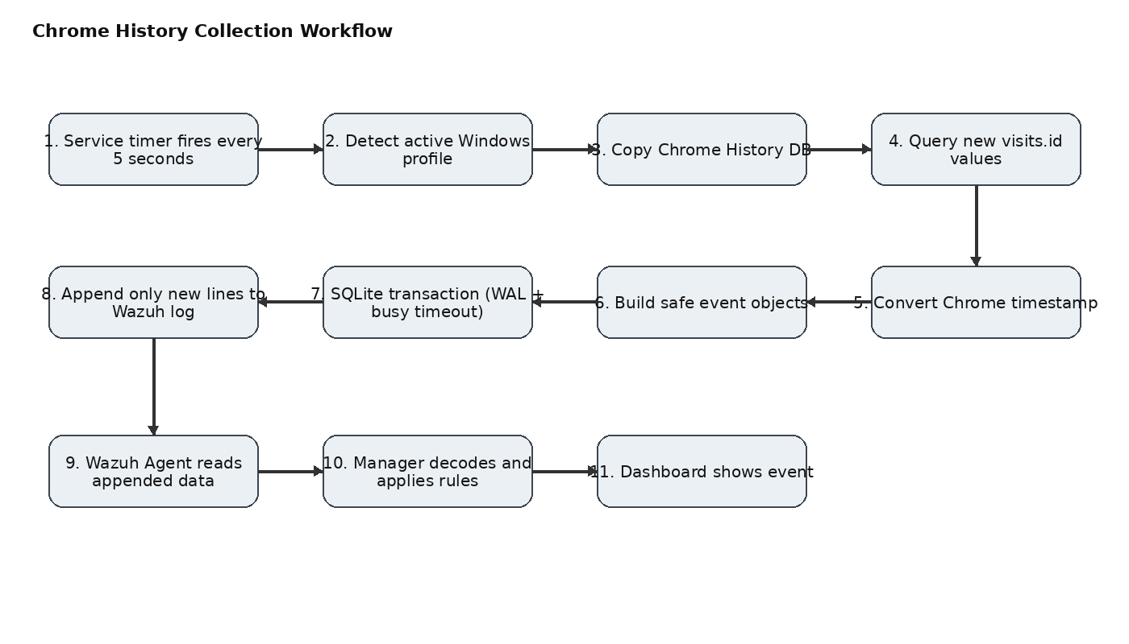
Figure 2 — Collection workflow
Service timer: The Windows service runs the collector immediately at startup and then every 5 seconds.
Active profile: The service queries Win32_ComputerSystem and derives the C:\Users\<user> profile.
Chrome source: collector.ps1 builds the Default Chrome History path.
SQLite path: The collector uses an explicit sqlite3.exe path because a service may not inherit the interactive user's PATH.
Archive initialization: If needed, the history table and indexes are created; WAL mode is enabled.
Persistent cursor: MAX(chrome_visit_id) from the archive becomes LastProcessedId.
Safe source read: The live Chrome History file is copied to a temporary DB before querying.
Incremental query: Only visits with visits.id greater than LastProcessedId are selected.
Normalization: Chrome timestamps are converted to local time and line breaks are removed.
Archive: All new records are inserted in one SQLite transaction.
Wazuh output: After a successful archive transaction, CHROME_HISTORY lines are appended to chrome_history.log.
Wazuh processing: The Agent forwards new log data; the Manager applies custom rules and the Dashboard displays the result.

5. Chrome History Tracking Model
The collector reads Chrome's local SQLite History database. The current implementation joins the visits and urls tables. Chrome's visits.id is used as the persistent event identifier and collection cursor.
SELECT
visits.id,
visits.visit_time,
urls.url,
urls.title
FROM visits
JOIN urls
ON visits.url = urls.id
WHERE visits.id > $LastProcessedId
ORDER BY visits.id ASC;

5.1 Why visits.id is used
- It is associated with each visit record.
- It gives the collector a simple monotonic cursor for incremental collection.
- The archive enforces uniqueness on chrome_visit_id.
- After restart, the cursor is reconstructed from the archive instead of relying on a separate state file.

5.2 Evolution from the first design
The earliest collector version used last_visit_time plus a separate state.txt file. During development, this was replaced by the current visit-ID model. The current implementation reads SELECT COALESCE(MAX(chrome_visit_id), 0) FROM history. This simplifies persistence and ties the cursor directly to archived events.
Archive cursor = MAX(chrome_visit_id)
New records = visits.id > Archive cursor
Successful archive + Wazuh append = progress

6. Chrome Timestamp Conversion
Chrome's visit_time is stored as microseconds since 1601-01-01 UTC. The collector converts that value into Windows FILETIME units by multiplying by 10, then converts it to local time.
$FileTime = [Int64]($ChromeTime * 10)
$VisitDate = [DateTime]::FromFileTimeUtc($FileTime).ToLocalTime()
$VisitTime = $VisitDate.ToString("yyyy-MM-dd HH:mm:ss")

7. SQLite Archive
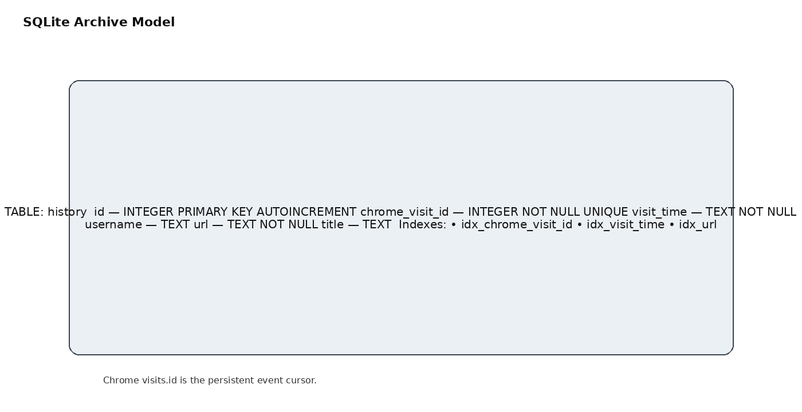
Figure 3 — Database model
CREATE TABLE IF NOT EXISTS history (
id INTEGER PRIMARY KEY AUTOINCREMENT,
chrome_visit_id INTEGER NOT NULL UNIQUE,
visit_time TEXT NOT NULL,
username TEXT,
url TEXT NOT NULL,
title TEXT
);
CREATE INDEX IF NOT EXISTS idx_chrome_visit_id ON history(chrome_visit_id);
CREATE INDEX IF NOT EXISTS idx_visit_time ON history(visit_time);
CREATE INDEX IF NOT EXISTS idx_url ON history(url);

7.1 Database purpose
- Persistent local archive.
- Duplicate prevention.
- Restart-safe progress tracking.
- Historical querying independent of Chrome.
- Stable handoff between source collection and Wazuh logging.

8. Solving the SQLite 'Database Is Locked' Error
An earlier design started sqlite3.exe for each individual INSERT. That increased the chance of competing database sessions. The current design builds all INSERT statements into one transaction and uses SQLite concurrency settings.
PRAGMA busy_timeout=10000;
PRAGMA journal_mode=WAL;
BEGIN IMMEDIATE TRANSACTION;
-- all INSERT OR IGNORE statements
COMMIT;
- WAL improves read/write concurrency.
- busy_timeout allows SQLite to wait for a lock.
- One transaction avoids repeatedly opening the archive for every row.
- INSERT OR IGNORE works with the UNIQUE chrome_visit_id constraint.
Additional protection The C# service uses Interlocked to ensure a second collector is not started while the previous collector is still running. This became important when polling was reduced to five seconds.

9. Windows Service
The original monitoring process depended on a visible or interactive PowerShell process. Closing that window stopped monitoring. The project was moved to a real Windows Service so the scheduler and lifetime are controlled by Windows Service Control Manager.
- Service name: ChromeHistoryMonitor.
- Runs independently of a visible PowerShell window.
- Starts the collector immediately.
- Runs every 5 seconds.
- Starts PowerShell with -NoProfile and -NonInteractive.
- Creates no visible window.
- Passes CHROME_USER_PROFILE to collector.ps1.
- Writes service lifecycle and exit-code information to service.log.
private const int CollectorIntervalMilliseconds = 5000;
timer = new Timer(
TimerCallback,
null,
CollectorIntervalMilliseconds,
CollectorIntervalMilliseconds
);
private int collectorRunning = 0;
private void TimerCallback(object state)
{
if (Interlocked.Exchange(ref collectorRunning, 1) == 1)
{
Log("Collector already running. Skipping this cycle.");
return;
}
try { RunCollector(); }
finally { Interlocked.Exchange(ref collectorRunning, 0); }
}
Operational rule Do not double-click the service executable. A service executable must be installed and started by Windows Service Control Manager. Use Start-Service or the Services console.

10. Files and Artifacts
Artifact | Purpose | Status
collector.ps1 | Chrome history collector. | Operational.
ChromeHistoryService.cs | C# service source. | Operational; 5-second timer + overlap guard.
ChromeHistoryService.exe | Compiled service binary. | Installed as service.
chrome_history_archive.db | SQLite archive/cursor. | Operational.
chrome_history.log | Wazuh input stream. | Operational.
collector.log | Collector status/errors. | Operational.
service.log | Service status/errors/exit codes. | Operational.
chrome_history.xml | Custom Wazuh rules. | Contains 100200 and collector-specific suppression.
Wazuh Agent configuration | localfile entry for chrome_history.log. | Configured.

11. Wazuh Agent Configuration
<localfile>
<location>C:\ProgramData\ChromeHistoryMonitor\chrome_history.log</location>
<log_format>syslog</log_format>
</localfile>
The collector does not directly call a Wazuh API. Instead, it appends normalized text events to a file that the Agent monitors. This makes the collector loosely coupled to Wazuh.

12. Wazuh Rules

12.1 Rule 100200 — Chrome history
<group name="chrome,web_history,windows,local,">
<rule id="100200" level="3">
<match>CHROME_HISTORY</match>
<description>Chrome web browsing history recorded on Windows endpoint.</description>
<group>chrome_history,</group>
</rule>
</group>

12.2 Rule 100201 — suppress collector-generated 91816 noise
<rule id="100201" level="0">
<if_sid>91816</if_sid>
<field name="win.eventdata.path" type="pcre2">(?i)C:\\ProgramData\\ChromeHistoryMonitor\\collector\.ps1</field>
<description>Ignore benign environment-variable access by Chrome History Monitor collector.</description>
<group>chrome_history,powershell,</group>
</rule>
Rule 91816 was triggered by PowerShell Script Block Logging from collector.ps1 because the collector legitimately reads environment variables. The suppression is scoped to the collector path rather than disabling 91816 globally.

12.3 Other observed noisy rules
- 92205 — PowerShell process created an executable file in Windows root folder (observed during testing).
- 92154 — Process loaded taskschd.dll module (observed during testing).
- These should only be suppressed after inspecting their full event fields and proving the exact collector-specific cause.
Design principle Never globally disable a security rule simply because the monitoring tool triggers some instances. Prefer a narrow child rule tied to the known collector path/process/context.

13. Event Format
CHROME_HISTORY user=Nauman Ahmad visit_id=6299 time=2026-09-12 03:51:19 url=https://example.com/ title=Example
Field | Meaning | Example
CHROME_HISTORY | Event prefix matched by rule 100200. | CHROME_HISTORY
user | Windows account associated with the collector. | Nauman Ahmad
visit_id | Chrome visits.id. | 6299
time | Converted local visit time. | 2026-09-12 03:51:19
url | Visited URL. | https://example.com/
title | Page title. | Example

14. End-to-End Timing
The collector polls every five seconds. That is the maximum collector-side polling window, not the total Wazuh latency. Once the collector appends a new line, the Wazuh Agent processes the monitored log independently.
Browser activity
↓
Chrome History DB
↓
0–5 seconds (collector polling)
↓
chrome_history.log
↓
Wazuh Agent
↓
Wazuh Manager / rules
↓
Dashboard
- No full-history resend occurs every five seconds.
- Only records newer than the archive cursor are emitted.
- Actual dashboard latency can be greater than five seconds because Wazuh ingestion/processing adds its own delay.

15. Verification and Troubleshooting

Service status
Get-Service ChromeHistoryMonitor

Service log
Get-Content "C:\ProgramData\ChromeHistoryMonitor\service.log" -Tail 20

Collector log
Get-Content "C:\ProgramData\ChromeHistoryMonitor\collector.log" -Tail 20

Wazuh output
Get-Content "C:\ProgramData\ChromeHistoryMonitor\chrome_history.log" -Tail 20

Service process
Get-CimInstance Win32_Process | Where-Object { $_.CommandLine -like "*collector.ps1*" } | Select-Object ProcessId, CommandLine

15.1 Healthy indicators
- Service status is Running.
- service.log shows collector completion approximately every five seconds.
- collector.log reports New events: 0 when there is no new browsing activity and a positive count when new visits appear.
- chrome_history.log receives only new CHROME_HISTORY lines.
- SQLite archive's maximum chrome_visit_id advances when new events are collected.
- No repeated database-is-locked errors.

16. Common Problems and Solutions
Problem | Cause | Solution
database is locked | Repeated SQLite sessions or overlapping collector runs. | Use WAL, busy_timeout, one transaction, and service overlap guard.
sqlite3.exe not found in PATH | Service environment differs from interactive shell. | Use an explicit sqlite3.exe path.
Monitoring stopped after closing PowerShell | Collector depended on interactive process. | Use the Windows Service.
Service executable start-failure dialog | Service binary was launched like a normal application. | Start through Service Control Manager.
Too many Wazuh alerts | Collector activity triggered built-in PowerShell rules. | Use narrow collector-specific suppression rules.
Duplicate history events | Previously processed records were reread. | Use visits.id cursor + SQLite archive.
No Wazuh events | Agent not monitoring the dedicated log or service/collector not writing. | Check service.log, collector.log, chrome_history.log, then Agent configuration.

17. Security, Privacy, and Deployment Notes
- Browsing history is sensitive telemetry; deploy only with authorization.
- Restrict write permissions on C:\ProgramData\ChromeHistoryMonitor so users cannot modify the collector or inject fake events.
- Protect the SQLite archive and logs.
- Do not globally suppress PowerShell security rules.
- Review URL logging for environments where query strings may contain sensitive values.
- The current SQLite executable path is under the developer user's profile because SQLite was installed through WinGet. For a junior/reusable deployment, use a stable machine-wide path or bundle sqlite3.exe with the application.
- The current active-user lookup is suitable for the tested single interactive-user scenario; multi-session/multi-profile environments need additional design.

18. Junior Rebuild Procedure
- Prepare a Windows endpoint with Chrome and a Wazuh Agent.
- Install SQLite and identify a stable sqlite3.exe path.
- Create C:\ProgramData\ChromeHistoryMonitor.
- Deploy collector.ps1 and replace any machine-specific paths.
- Run the collector manually once to initialize the archive and verify output.
- Verify chrome_history_archive.db contains the history table and indexes.
- Create chrome_history.xml on the Wazuh Manager with rule 100200.
- Add the localfile entry to the Agent configuration.
- Restart the Agent and verify CHROME_HISTORY events arrive.
- Build/install ChromeHistoryService.exe and register ChromeHistoryMonitor.
- Start the service using the Service Control Manager.
- Verify five-second collector execution and no overlap/SQLite errors.
- Inspect Wazuh PowerShell noise and add narrowly scoped suppressions only after reviewing real event fields.
- Reboot the endpoint and verify the service restarts without an interactive PowerShell window.
- Only after the history pipeline is stable should upload detection be implemented.

19. Planned Phase 2 — Upload Detection
The current pipeline is intentionally the foundation. Chrome history alone cannot establish that a file was uploaded. A robust upload detector should correlate multiple signals rather than treating a visit to an upload page as proof.
File activity
+
Browser/process identity
+
Network destination/activity
+
Time correlation
↓
Upload candidate
↓
Correlation logic
↓
UPLOAD_ACTIVITY
↓
Wazuh
- Establish reliable process/browser telemetry.
- Capture relevant file activity around the event.
- Capture network destination/activity where appropriate.
- Correlate timestamps, process identity, file path and destination.
- Emit a separate UPLOAD_ACTIVITY event.
- Keep CHROME_HISTORY unchanged as contextual telemetry.

Appendix A — Current Collector Reference
$ErrorActionPreference = "Stop"
$BaseDir = "C:\ProgramData\ChromeHistoryMonitor"
$ArchiveDb = Join-Path $BaseDir "chrome_history_archive.db"
$WazuhLog = Join-Path $BaseDir "chrome_history.log"
$CollectorLog = Join-Path $BaseDir "collector.log"
$ChromeUserProfile = $env:CHROME_USER_PROFILE
if ([string]::IsNullOrWhiteSpace($ChromeUserProfile)) {
$ChromeUserProfile = $env:USERPROFILE
}
if ([string]::IsNullOrWhiteSpace($ChromeUserProfile)) {
Write-CollectorLog "ERROR Chrome user profile could not be determined"
exit 1
}
$ChromeHistory = Join-Path $ChromeUserProfile `
"AppData\Local\Google\Chrome\User Data\Default\History"
$TempDb = Join-Path $env:TEMP `
"chrome_history_copy_$($env:USERNAME).db"
$SqliteExe = "C:\Users\<USER>\AppData\Local\Microsoft\WinGet\Links\sqlite3.exe"
function Write-CollectorLog {
param([string]$Message)
$Timestamp = Get-Date -Format "yyyy-MM-dd HH:mm:ss"
"$Timestamp $Message" |
Out-File -FilePath $CollectorLog -Append -Encoding UTF8
}
if (-not (Test-Path $SqliteExe)) {
Write-CollectorLog "ERROR sqlite3.exe not found at $SqliteExe"
exit 1
}
if (-not (Test-Path $ChromeHistory)) {
Write-CollectorLog "Chrome history database not found: $ChromeHistory"
exit 0
}
if (-not (Test-Path $ArchiveDb)) {
$CreateDb = @"
PRAGMA journal_mode=WAL;
CREATE TABLE IF NOT EXISTS history (
id INTEGER PRIMARY KEY AUTOINCREMENT,
chrome_visit_id INTEGER NOT NULL UNIQUE,
visit_time TEXT NOT NULL,
username TEXT,
url TEXT NOT NULL,
title TEXT
);
CREATE INDEX IF NOT EXISTS idx_chrome_visit_id ON history(chrome_visit_id);
CREATE INDEX IF NOT EXISTS idx_visit_time ON history(visit_time);
CREATE INDEX IF NOT EXISTS idx_url ON history(url);
"@
$CreateDb | & $SqliteExe $ArchiveDb
if ($LASTEXITCODE -ne 0) {
Write-CollectorLog "ERROR failed to create archive database"
exit 1
}
}
"PRAGMA busy_timeout=10000; PRAGMA journal_mode=WAL;" |
& $SqliteExe $ArchiveDb | Out-Null
$StateQuery = @"
SELECT COALESCE(MAX(chrome_visit_id), 0)
FROM history;
"@
$StateOutput = & $SqliteExe $ArchiveDb $StateQuery 2>$null
$LastProcessedId = 0
if ($StateOutput -match '^\d+$') {
$LastProcessedId = [Int64]$StateOutput.Trim()
}
Remove-Item $TempDb -Force -ErrorAction SilentlyContinue
try {
Copy-Item -Path $ChromeHistory -Destination $TempDb -Force
}
catch {
Write-CollectorLog "ERROR unable to copy Chrome History database: $($_.Exception.Message)"
exit 1
}
$Query = @"
SELECT visits.id, visits.visit_time, urls.url, urls.title
FROM visits
JOIN urls ON visits.url = urls.id
WHERE visits.id > $LastProcessedId
ORDER BY visits.id ASC;
"@
$Rows = @(
& $SqliteExe -separator "|" $TempDb $Query 2>$null
)
if ($Rows.Count -eq 0) {
Remove-Item $TempDb -Force -ErrorAction SilentlyContinue
Write-CollectorLog "Collection completed. New events: 0. Last visit ID: $LastProcessedId"
exit 0
}
$Events = New-Object System.Collections.Generic.List[object]
$MaxVisitId = $LastProcessedId
foreach ($Row in $Rows) {
if ([string]::IsNullOrWhiteSpace($Row)) { continue }
$Parts = $Row -split '\|', 4
if ($Parts.Count -lt 3) { continue }
try {
$ChromeVisitId = [Int64]$Parts[0]
$ChromeTime = [Int64]$Parts[1]
} catch { continue }
$Url = $Parts[2]
$Title = ""
if ($Parts.Count -eq 4) { $Title = $Parts[3] }
if ($ChromeVisitId -gt $MaxVisitId) {
$MaxVisitId = $ChromeVisitId
}
try {
$FileTime = [Int64]($ChromeTime * 10)
$VisitDate = [DateTime]::FromFileTimeUtc($FileTime).ToLocalTime()
$VisitTime = $VisitDate.ToString("yyyy-MM-dd HH:mm:ss")
} catch { continue }
$SafeUrl = $Url -replace '[\r\n]', ''
$SafeTitle = $Title -replace '[\r\n]', ''
$SafeUser = $env:USERNAME -replace '[\r\n]', ''
$Events.Add([PSCustomObject]@{
ChromeVisitId = $ChromeVisitId
VisitTime = $VisitTime
Username = $SafeUser
Url = $SafeUrl
Title = $SafeTitle
})
}
if ($Events.Count -eq 0) {
Remove-Item $TempDb -Force -ErrorAction SilentlyContinue
Write-CollectorLog "Collection completed. New events: 0. Last visit ID: $LastProcessedId"
exit 0
}
$SqlCommands = New-Object System.Text.StringBuilder
[void]$SqlCommands.AppendLine("PRAGMA busy_timeout=10000;")
[void]$SqlCommands.AppendLine("PRAGMA journal_mode=WAL;")
[void]$SqlCommands.AppendLine("BEGIN IMMEDIATE TRANSACTION;")
foreach ($Event in $Events) {
$DbUser = $Event.Username.Replace("'", "''")
$DbUrl = $Event.Url.Replace("'", "''")
$DbTitle = $Event.Title.Replace("'", "''")
$DbVisitTime = $Event.VisitTime.Replace("'", "''")
[void]$SqlCommands.AppendLine(@"
INSERT OR IGNORE INTO history
(chrome_visit_id, visit_time, username, url, title)
VALUES
($($Event.ChromeVisitId), '$DbVisitTime', '$DbUser', '$DbUrl', '$DbTitle');
"@)
}
[void]$SqlCommands.AppendLine("COMMIT;")
try {
$SqlCommands.ToString() | & $SqliteExe $ArchiveDb
if ($LASTEXITCODE -ne 0) {
throw "SQLite transaction failed with exit code $LASTEXITCODE"
}
}
catch {
Write-CollectorLog "ERROR archive transaction failed: $($_.Exception.Message)"
Remove-Item $TempDb -Force -ErrorAction SilentlyContinue
exit 1
}
foreach ($Event in $Events) {
$WazuhEvent =
"CHROME_HISTORY user=$($Event.Username) visit_id=$($Event.ChromeVisitId) time=$($Event.VisitTime) url=$($Event.Url) title=$($Event.Title)"
try {
$WazuhEvent |
Out-File -FilePath $WazuhLog -Append -Encoding UTF8
}
catch {
Write-CollectorLog "ERROR failed writing Wazuh event for visit ID $($Event.ChromeVisitId): $($_.Exception.Message)"
}
}
Remove-Item $TempDb -Force -ErrorAction SilentlyContinue
Write-CollectorLog "Collection completed. New events: $($Events.Count). Last visit ID: $MaxVisitId"

Appendix B — Current Windows Service Reference
using System;
using System.Diagnostics;
using System.IO;
using System.Management;
using System.ServiceProcess;
using System.Threading;
public class ChromeHistoryService : ServiceBase
{
private Timer timer;
private int collectorRunning = 0;
private const string BaseDir =
@"C:\ProgramData\ChromeHistoryMonitor";
private const string Collector =
@"C:\ProgramData\ChromeHistoryMonitor\collector.ps1";
private const string ServiceLog =
@"C:\ProgramData\ChromeHistoryMonitor\service.log";
private const int CollectorIntervalMilliseconds = 5000;
public ChromeHistoryService()
{
ServiceName = "ChromeHistoryMonitor";
CanStop = true;
CanPauseAndContinue = false;
AutoLog = false;
}
protected override void OnStart(string[] args)
{
Log("Chrome History Monitor service started.");
RunCollector();
timer = new Timer(
TimerCallback,
null,
CollectorIntervalMilliseconds,
CollectorIntervalMilliseconds
);
}
private void TimerCallback(object state)
{
if (Interlocked.Exchange(ref collectorRunning, 1) == 1)
{
Log("Collector already running. Skipping this cycle.");
return;
}
try { RunCollector(); }
finally { Interlocked.Exchange(ref collectorRunning, 0); }
}
private void RunCollector()
{
try
{
string profile = GetActiveUserProfile();
if (String.IsNullOrWhiteSpace(profile))
{
Log("No active interactive user found.");
return;
}
if (!File.Exists(Collector))
{
Log("ERROR collector.ps1 not found.");
return;
}
ProcessStartInfo psi = new ProcessStartInfo();
psi.FileName = "powershell.exe";
psi.Arguments =
"-NoProfile " +
"-NonInteractive " +
"-ExecutionPolicy Bypass " +
"-File \"" + Collector + "\"";
psi.UseShellExecute = false;
psi.CreateNoWindow = true;
psi.WindowStyle = ProcessWindowStyle.Hidden;
psi.EnvironmentVariables["CHROME_USER_PROFILE"] = profile;
using (Process process = Process.Start(psi))
{
process.WaitForExit();
Log(
"Collector finished. Exit code: " +
process.ExitCode +
". Profile: " +
profile
);
}
}
catch (Exception ex)
{
Log("ERROR: " + ex.ToString());
}
}
private string GetActiveUserProfile()
{
try
{
ManagementObjectSearcher searcher =
new ManagementObjectSearcher(
"SELECT UserName FROM Win32_ComputerSystem"
);
foreach (ManagementObject obj in searcher.Get())
{
string username = obj["UserName"] as string;
if (String.IsNullOrWhiteSpace(username))
continue;
string userOnly = username;
int slash = username.IndexOf('\\');
if (slash >= 0)
userOnly = username.Substring(slash + 1);
string profile =
Path.Combine(@"C:\Users", userOnly);
if (Directory.Exists(profile))
return profile;
}
}
catch (Exception ex)
{
Log("ERROR detecting active user: " + ex.Message);
}
return null;
}
protected override void OnStop()
{
Log("Chrome History Monitor service stopping.");
if (timer != null)
{
timer.Dispose();
timer = null;
}
Interlocked.Exchange(ref collectorRunning, 0);
}
private void Log(string message)
{
try
{
Directory.CreateDirectory(BaseDir);
string line =
DateTime.Now.ToString("yyyy-MM-dd HH:mm:ss") +
" " + message;
File.AppendAllText(
ServiceLog,
line + Environment.NewLine
);
}
catch
{
}
}
public static void Main()
{
ServiceBase.Run(
new ChromeHistoryService()
);
}
}

Appendix C — Wazuh Configuration Reference
<localfile>
<location>C:\ProgramData\ChromeHistoryMonitor\chrome_history.log</location>
<log_format>syslog</log_format>
</localfile>
<group name="chrome,web_history,windows,local,">
<rule id="100200" level="3">
<match>CHROME_HISTORY</match>
<description>Chrome web browsing history recorded on Windows endpoint.</description>
<group>chrome_history,</group>
</rule>
<rule id="100201" level="0">
<if_sid>91816</if_sid>
<field name="win.eventdata.path" type="pcre2">(?i)C:\\ProgramData\\ChromeHistoryMonitor\\collector\.ps1</field>
<description>Ignore benign environment-variable access by Chrome History Monitor collector.</description>
<group>chrome_history,powershell,</group>
</rule>
</group>

Appendix D — Operational Command Checklist
# Service
Get-Service ChromeHistoryMonitor
# Start / stop
Start-Service ChromeHistoryMonitor
Stop-Service ChromeHistoryMonitor
# Service log
Get-Content "C:\ProgramData\ChromeHistoryMonitor\service.log" -Tail 20
# Collector log
Get-Content "C:\ProgramData\ChromeHistoryMonitor\collector.log" -Tail 20
# Wazuh log
Get-Content "C:\ProgramData\ChromeHistoryMonitor\chrome_history.log" -Tail 20
# Service/collector process
Get-CimInstance Win32_Process |
Where-Object { $_.CommandLine -like "*collector.ps1*" } |
Select-Object ProcessId, CommandLine

Appendix E — Source Basis
This report consolidates the implementation built in the project conversation and the captured Wazuh event evidence. The captured event confirms collector.ps1 at C:\ProgramData\ChromeHistoryMonitor\collector.ps1, Event ID 4104 Script Block Logging, rule 91816, and the collector's use of the SQLite archive and CHROME_HISTORY output. The current collector source also documents the visits.id cursor, WAL/busy_timeout transaction model, and post-transaction Wazuh logging. filecite markers in the source artifact were used where applicable.
Baseline for Phase 2 Do not modify the CHROME_HISTORY event contract when implementing upload detection. Add a separate UPLOAD_ACTIVITY event so existing dashboards, rules, and history collection remain stable.

CURRENT PROJECT IMPLEMENTATION
Chrome History & Upload Monitor — Consolidated Deployment Guide
Updated to reflect the current multi-user installer, Windows service, 10-second history polling target, and Chrome upload MVP.

20. Current Implementation at a Glance
The project now combines two endpoint telemetry paths: (1) Chrome browsing-history collection and (2) Chrome upload activity detection. Both are installed under the same program directory. The Windows service is responsible for upload detection and background execution; the Chrome history collector is scheduled in the SYSTEM context so it can inspect Windows user Chrome profiles.
Component | Current value | Purpose
Program directory | C:\ProgramData\ChromeHistoryMonitor | Common runtime/data directory
History collector | collector.ps1 | Reads new Chrome History records
History polling | 10 seconds | Near-real-time polling target
History task | Chrome History Monitor | Runs the collector silently as SYSTEM
Upload service | Chrome Upload Detector | Windows service for upload receiver
Upload listener | TCP 8765 | Receives upload activity from the extension
SQLite | sqlite3.exe | Archive and persistent cursor
History output | chrome_history.log | Wazuh-monitored history stream
Upload output | chrome_upload.log | Wazuh-monitored upload stream
Chrome extension | ChromeUploadDetector-MVP | Detects upload-related browser activity

21. Multi-User Windows Design
The endpoint may contain multiple Windows accounts, for example an administration account, a PC support account, and multiple ordinary user accounts. The design therefore keeps PC identity separate from the browser username. The Wazuh Agent supplies the endpoint identity, so events from a machine such as LMC-1 or LMC-2 can be associated with that endpoint in Wazuh while the event itself records the Windows user/profile where available.
The installed collector creates per-user/profile state such as:
state_Administrator_Default.txt
state_pcsupport_Default.txt
This prevents one user's Chrome visit cursor from being treated as another user's cursor. The current collector also uses the Windows user profile path when locating Chrome's History database.

22. Complete End-to-End Workflow
The following flow represents the combined implementation. Chrome history and upload telemetry remain separate event streams so existing CHROME_HISTORY processing is not changed when upload monitoring is added.
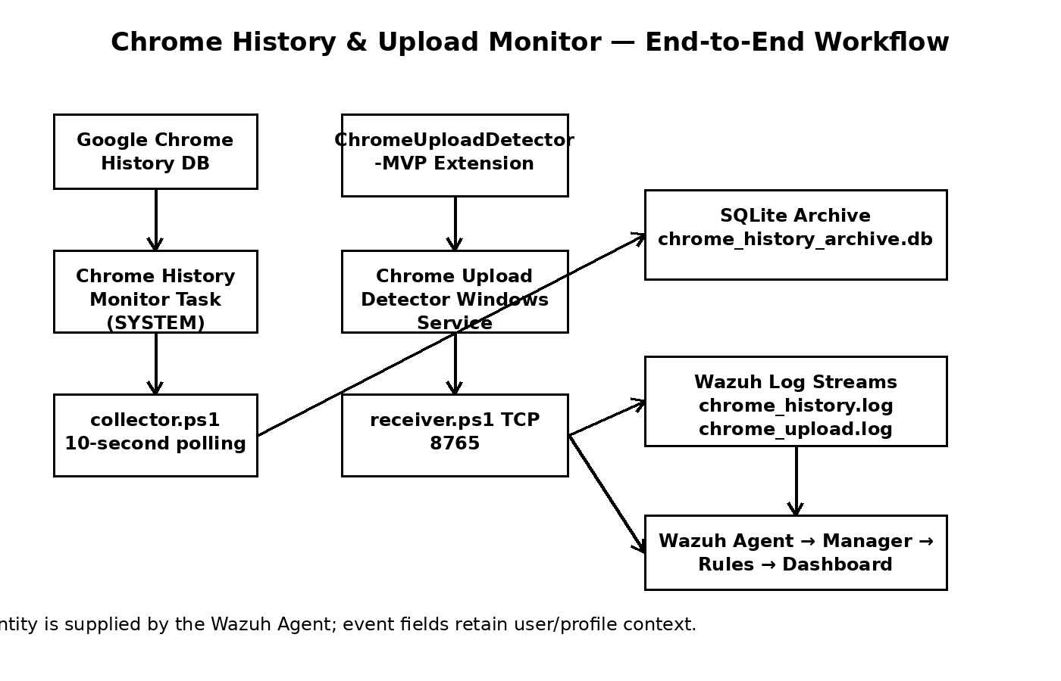

23. Installer Responsibilities
The installer is designed to make deployment repeatable instead of requiring manual setup. The current installer performs the following sequence:
- Check required installation files.
- Create C:\ProgramData\ChromeHistoryMonitor.
- Stop previous components before replacing binaries.
- Remove an existing Chrome Upload Detector service when present.
- Install collector.ps1, receiver.ps1, the upload service executable and SQLite.
- Copy the ChromeUploadDetector-MVP directory into the common ProgramData directory.
- Validate collector.ps1 PowerShell syntax before registering the monitor.
- Initialize/verify the multi-user SQLite archive.
- Create the Chrome History Monitor scheduled task as SYSTEM and configure hidden execution.
- Configure the upload detector as an Automatic LocalSystem Windows service.
- Start both monitoring components and verify their status.
- Verify the upload listener on port 8765 and installed runtime artifacts.
Important: A Scheduled Task is used for the multi-user history collector because the collector must inspect multiple Windows user Chrome profiles. The upload detector itself is a Windows service.

24. Chrome Upload Detector MVP
The upload MVP consists of a Chrome extension and a PowerShell receiver. The extension detects relevant browser upload activity and sends a local event to the receiver. The receiver writes normalized events to C:\ProgramData\ChromeHistoryMonitor\chrome_upload.log. Wazuh can monitor that file independently of the history stream.
Installed extension directory:
C:\ProgramData\ChromeHistoryMonitor\ChromeUploadDetector-MVP\ChromeUploadDetector-MVP
Manual Chrome installation procedure:
- Open Google Chrome.
- Open chrome://extensions/.
- Enable Developer mode.
- Select Load unpacked.
- Browse to C:\ProgramData\ChromeHistoryMonitor\ChromeUploadDetector-MVP\ChromeUploadDetector-MVP.
- Select the extension folder containing the extension manifest.
- Confirm that the Chrome Upload Detector extension appears in the extensions list and is enabled.
- Perform a controlled upload test and verify chrome_upload.log and the Wazuh event stream.
Deployment note: Because the extension is loaded unpacked, Chrome may display a developer-mode warning. In an enterprise environment, extension deployment should be handled through the organization's approved Chrome management mechanism where applicable.

25. Wazuh Agent Configuration
The history stream is configured as a monitored local file:
<localfile>
<location>C:\ProgramData\ChromeHistoryMonitor\chrome_history.log</location>
<log_format>syslog</log_format>
</localfile>
For the upload stream, use the same localfile pattern with the upload log:
<localfile>
<location>C:\ProgramData\ChromeHistoryMonitor\chrome_upload.log</location>
<log_format>syslog</log_format>
</localfile>
The exact placement of these entries depends on the Wazuh Agent configuration structure used by the organization's Windows agent deployment. After modifying the configuration, restart the Wazuh Agent and verify that the monitored files are being ingested.

26. Wazuh Custom Rules
History rule — 100200:
<group name="chrome,web_history,windows,local,">
<rule id="100200" level="3">
<match>CHROME_HISTORY</match>
<description>Chrome web browsing history recorded on Windows endpoint.</description>
<group>chrome_history,</group>
</rule>
</group>
Collector-specific PowerShell suppression — 100201:
<rule id="100201" level="0">
<if_sid>91816</if_sid>
<field name="win.eventdata.path" type="pcre2">(?i)C:\\ProgramData\\ChromeHistoryMonitor\\collector\.ps1</field>
<description>Ignore benign environment-variable access by Chrome History Monitor collector.</description>
<group>chrome_history,powershell,</group>
</rule>
Upload rule — 100202 (the upload MVP event stream):
<rule id="100202" level="5">
<match>UPLOAD_ACTIVITY</match>
<description>Chrome upload activity detected on Windows endpoint.</description>
<group>chrome_upload,chrome,windows,</group>
</rule>
Rule design: Keep suppressions narrow. Do not globally disable PowerShell security rules merely because the collector generates some legitimate PowerShell telemetry.

27. Sysmon Integration
Sysmon is used as supporting endpoint telemetry rather than as the Chrome History database reader. The project can use Sysmon events to provide process/file/network context for future upload correlation. The existing project documentation specifically observed PowerShell Script Block Logging rule 91816 and testing noise involving rules 92205 and 92154.
Recommended deployment principle:
- Install Sysmon on Windows endpoints using an organization-approved Sysmon configuration.
- Collect process creation, network connection and relevant file/process telemetry needed for upload correlation.
- Use Wazuh to ingest Sysmon Windows Event Log data.
- Do not suppress Sysmon events solely because the monitoring software generated them; inspect the complete event fields first.
- Use the narrowest possible child/suppression rule when a collector-generated event is proven benign.
Source limitation: The earlier project report does not contain a complete Sysmon XML configuration file. It documents the Sysmon/Wazuh design principle and observed Wazuh rules, so a site-specific Sysmon XML should be treated as a deployment artifact rather than invented here.

28. Event Formats
Chrome history event:
CHROME_HISTORY user=<WindowsUser> profile=<ChromeProfile> visit_id=<ID> time=<LOCAL_TIME> url=<URL> title=<TITLE>
Upload activity event:
UPLOAD_ACTIVITY ...
The upload event contract should remain separate from CHROME_HISTORY. This preserves existing history dashboards, rules and searches while allowing upload detection to evolve independently.

29. Verification Checklist
Get-Service "Chrome Upload Detector" | Select Name,Status,StartType
Get-ScheduledTask -TaskName "Chrome History Monitor" | Select TaskName,State
Get-Content "C:\ProgramData\ChromeHistoryMonitor\collector.log" -Tail 20
Get-Content "C:\ProgramData\ChromeHistoryMonitor\chrome_history.log" -Tail 20
Get-Content "C:\ProgramData\ChromeHistoryMonitor\chrome_upload.log" -Tail 20
Test-Path "C:\ProgramData\ChromeHistoryMonitor\sqlite3.exe"
Get-NetTCPConnection -LocalPort 8765 -ErrorAction SilentlyContinue
Get-ScheduledTaskInfo -TaskName "Chrome History Monitor" | Select LastRunTime,NextRunTime,LastTaskResult

30. Troubleshooting Lessons from Development
Problem | Cause | Resolution
Visible PowerShell window appeared periodically | An earlier design used a one-minute Scheduled Task that launched PowerShell interactively. | Move persistent background work into a Windows service or use a hidden SYSTEM task for the collector.
Scheduled task returned a one-minute cadence | The task trigger was configured for one-minute repetition. | The current target is 10-second collection; Windows Task Scheduler has interval limitations, so a continuously running collector loop is preferable for sub-minute polling.
Task XML rejected PT10S | Windows Task Scheduler rejected a 10-second repetition interval in the task XML. | Do not rely on a 10-second Task Scheduler repetition pattern; run the collector continuously with Start-Sleep -Seconds 10 inside the task process, or use the service architecture.
collector.ps1 syntax validation failed | A PowerShell here-string footer had whitespace before its terminator. | Here-string closing markers must begin at column zero. Validate with Parser::ParseFile before installing.
Old single-user archive schema error | An existing archive was created with the earlier schema. | Back up/remove the old archive when migrating to the multi-user schema so the installer can create the new database.
sqlite3.exe not found | The service environment may not inherit the interactive user's PATH. | Use the explicit installed sqlite3.exe path under ProgramData.
SQLite database locked | Multiple SQLite sessions/overlapping collector runs competed for the archive. | Use WAL, busy_timeout, one transaction per collection cycle and an overlap guard.
No Wazuh events | The Agent may not be monitoring the dedicated log or the collector may not be writing. | Check service/collector logs, then the Wazuh Agent localfile configuration and Manager rules.

31. Security, Privacy and Operational Considerations
- Browsing history is sensitive endpoint telemetry and should only be collected under appropriate organizational authorization.
- Protect C:\ProgramData\ChromeHistoryMonitor and restrict write access to runtime files.
- Protect SQLite archives and log files from unauthorized modification.
- Review URL query strings because they can contain sensitive information.
- Do not globally suppress security telemetry.
- Keep the Wazuh Agent responsible for endpoint identity so the same software can operate on PCs such as LMC-1 and LMC-2.
- Use the upload detector as telemetry/correlation evidence; browser history alone is not proof that a file was uploaded.
- For production deployments, package and manage the Chrome extension through the organization's approved browser-management process rather than relying on manual unpacked loading.

32. Final Deployment Architecture
A fresh endpoint deployment should result in one common ProgramData directory containing the collector, receiver, service binary, SQLite executable, logs, archive and ChromeUploadDetector-MVP extension directory. The Wazuh Agent identifies the endpoint; the history collector supplies browser/user context; the upload service supplies upload activity; the Wazuh Manager applies rules; and the Dashboard provides the operational view.

33. Project Artifact Layout
C:\ProgramData\ChromeHistoryMonitor\
│
├── collector.ps1
├── receiver.ps1
├── ChromeUploadDetectorService.exe
├── sqlite3.exe
├── ChromeUploadDetector-MVP\
│ └── ChromeUploadDetector-MVP\
│ └── <Chrome extension files>
│
├── chrome_history_archive.db
├── chrome_history.log
├── chrome_upload.log
├── collector.log
├── service-host.log
├── receiver.log
├── state_Administrator_Default.txt
├── state_pcsupport_Default.txt
└── service.log

